|  |  |  |  |
| --- | --- | --- | --- |
| 1 | | 2,868.0 | |
| NUMERO DE FRONTERAS | | ENERGIA AGREGADA | |
|  | | | |
| NO | | 0 | |
| CONTRATO | | VENCIMIENTO CONTRATO | |
|  | | | |
| 7,928,572 | 60 | | 283,090 |
| INGRESO 2020 | DÍAS CERTIFICADOS 2020 | | ENERGIA RESPALDADA 2020 |
|  | | | |
| 964,916 | 14 | | 39,978 |
| INGRESO 2021 | DÍAS CERTIFICADOS 2021 | | ENERGIA RESPALDADA 2021 |

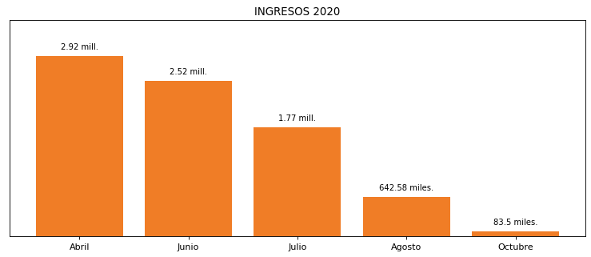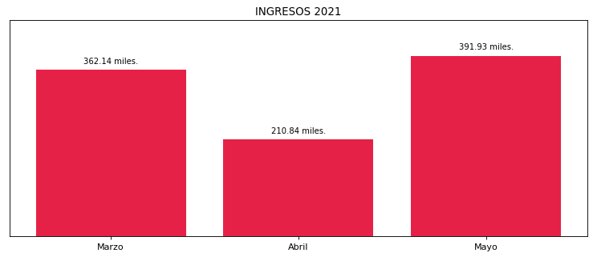

|  |
| --- |
| **HOTEL EL DORADO**  USUARIO |

|  |
| --- |
| **Edwin Torres**  Ejecutivo de cuenta |

|  |
| --- |
| **William Monroy / Gerente General / 0**  Primera fecha: PUNTO FOCAL |

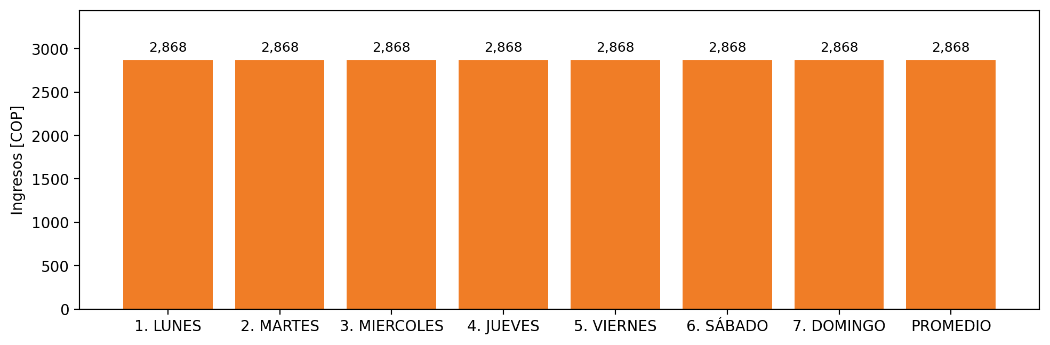

|  |  |  |  |  |  |  |  |  |  |
| --- | --- | --- | --- | --- | --- | --- | --- | --- | --- |
| **FRONTERA COMERCIAL** | **TIPO DDV** | **COD SIC** | **PREDIO** | **PROMEDIO** | **MARGEN** | **ÚLTIMA DESCONEXION** | **DÍAS CERTIFICADOS** | **ACTUALIZACION** | **PROXIMA PRUEBA DDV** |
| HOTEL EL DORADO | Frt35877 | Frt00827 | Prd01512 | 2,868 | 4,29 | 2020-04-03 | 74.0 | 2022-03-02 | 2021-11-30 |